29

ULSTER COUNTY NEWS

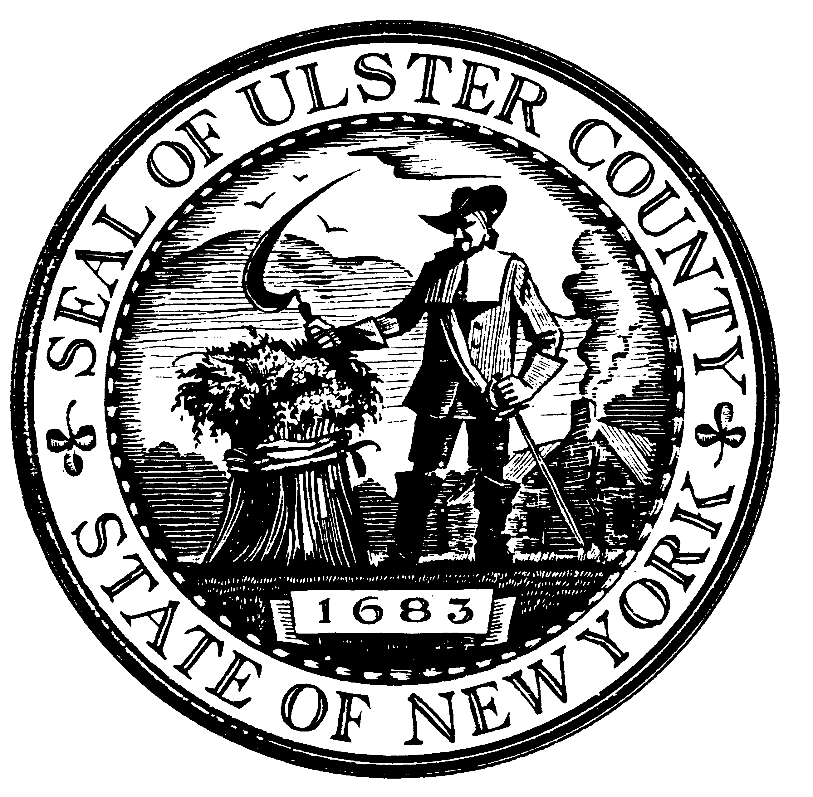

ULSTER COUNTY NEWS INFORMATION 845.340.3900

OFFICE OF ULSTER COUNTY LEGISLATURE FAX: 845.340.3651

244 FAIR STREET www.co.ulster.ny.us

KINGSTON, NEW YORK 12401 www.ulstercountyny.gov

**Weekly Update For The Week Of**

**March 23 – March 27, 2020**

|  |  |
| --- | --- |
| Monday, March 23 | **No Meetings** |
| Tuesday, March 24 | **No Meetings** |
| **Wednesday, March 25** | **4:30 PM – Ulster County Economic Development Alliance Audit Committee Meeting** via Zoom Video Meeting with public access by telephone at XXX-XXX-XXXX  **5:00 PM (or immediately following the UCEDA Audit Committee) – Ulster County Economic Development Alliance Board of Directors** via Zoom Video Meeting with public access by telephone at XXX-XXX-XXXX |
| Thursday, March 26 | **No Meetings** |
| Friday, March 27 | **12:00 PM – Resolution Deadline** |